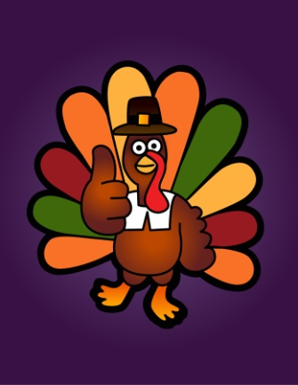
THANKSGIVING DAY
- Complete the gaps with one of the words in the box
Voyage fourth colony second Puritans corn ship hunt Pilgrim Fathers founders harvest
Americans of all religions celebrate Thanksgiving on the ______________ Thursday of November. Children do not go to school, and most businesses close for four days. People in Canada also celebrate Thanksgiving, but they celebrate it on the _____________ Monday in October.
Thanksgiving is a special day for families, and people travel great distances to be with their families for this occasion.
Why is Thanksgiving and Important Day?
The tradition started with the “__________________”. They were the _____________ of a ____________ in North America. These people were ___________ . They were against the Church of England, and suffered religious persecution in England. They wanted to start a new life in a new country.
Eventually, on 6 September 1620, 102 men, women and children left Plymouth in south-west England on a ______________ called the Mayflower. The ___________was difficult: two Pilgrims died, but two were born. On 11 December 1620 they landed on the north-east coast of North America. They called this are Plymouth. It was almost winter and there wasn’t much food. They immediately built small houses, but it was too late to grow crops. The winter was very long and cold and half of the Pilgrims died.
In the spring a native American called Squanto helped the Pilgrims. He taught them how to grow ___________ and how to __________ and fish. Soon the Pilgrims and the Wampanoag native Americans became friends. The Pilgrims grew crops and the summer _________ was excellent. By November 1621 everyone had food and a home. There was hope for the future.
William Bradford was the governor of the Pilgrim’s colony. He decided to celebrate with a dinner for the Pilgrims and about ninety native Americans. He wanted to thank God. This was the first Thanksgiving dinner, and it continued for three days.
- How is Thanksgiving celebrated today?

